The reaction taking place in the CSTR is:

(CH3CO)2O + H2O 🡪 2CH3COOH

or A + W 🡪 2P

-rA = kCACW = 0.0075 CACW mol/l.s

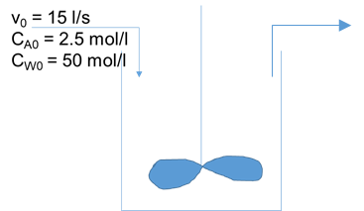

The performance equation for a CSTR is given as:

$$\frac{V}{ν_{0}}=\frac{{C_{A0}X}_{A}}{\left(-r_{A}\right)}$$

Substituting,

$$\frac{1250}{15}=\frac{2.5{*X}_{A}}{0.0075{ C}_{A}C_{W}}$$

For a liquid-phase reaction, under constant volume conditions,

$${ C}_{A}=C_{A0}(1 - X_{A})$$

And concentration of water based on 1:1 stoichiometric coefficients of the reactants in the balanced equation, can be written as,

$${ C}_{W}=C_{W0}- {C_{A0}X}_{A}$$

Substituting in performance equation,

$$\frac{1250}{15}=\frac{2.5{*X}_{A}}{0.0075*2.5 \left(1 - X_{A}\right)*(50- {2.5 X}_{A})}$$

Solving the above equation,

XA = 0.97